American International University-Bangladesh (AIUB)


Department of Computer Science
Faculty of Science and Technology
Final Term Project Documentation
Topic Name :
Student Details
Student Name | Student ID | Contributed Topic | Percentage%
MD. SHADMAN SHAKIB ALAM | 22-46262-1 | Normalization, Design | 25%
RIMON PRAMANIK | 22-46957-1 | Schema diagram, Design | 25%
LAMIA TAHSIN | 22-46345-1 | PL/SQL, Design | 25%
MARUF AHMEND | 22-46354-1 | Relational Algebra, Design | 25%
Outdoor Sports Facility Management System

Submission Date: September 16, 2025

Updated:
- NORMALIZATION:
Relation 1: Can Manage (Staff Member Can Manage Event)
UNF:
Can_Manage(Staff_ID, First_Name, Last_Name, Department, Event_ID, Event_Name, Date, Rules)
1NF:
No multivalued attributes, so it remains
1. Staff_ID, First_Name, Last_Name, Department, Event_ID, Event_Name, Date, Rules
2NF:
Staff details depend on Staff_ID
Event details depend on Event_ID.
1. Staff_ID, First_Name, Last_Name, Department
2. Event_ID, Event_Name, Date, Rules
3. Staff_ID, Event_ID
3NF:
No Transitive dependencies.
1. Staff_ID, First_Name, Last_Name, Department
2. Event_ID, Event_Name, Date, Rules
3. Staff_ID, Event_ID
Table Creation:
Staff_Member(Staff_ID (PK), First_Name, Last_Name, Department)
Event(Event_ID (PK), Event_Name, Date, Rules)
Can_Manage(Staff_ID(FK), Event_ID(FK))

Relation 2: Participates (Event Participates in Team)
UNF:
Participates(Event_ID, Event_Name, Date, Rules, Team_ID, Team_Name, Sport_Type)
1NF:
No multivalued attributes, so it remains
1. Event_ID, Event_Name, Date, Rules, Team_ID, Team_Name, Sport_Type

2NF:
Event details depend on Event_ID.
Team details depend on Team_ID.
1. Event_ID, Event_Name, Date, Rules
2. Team_ID, Team_Name, Sport_Type
3. Event_ID, Team_ID

3NF:
No Transitive dependencies.
1. Event_ID, Event_Name, Date, Rules
2. Team_ID, Team_Name, Sport_Type
3. Event_ID, Team_ID

Table Creation:
Event(Event_ID(PK), Event_Name, Date, Rules)
Team(Team_ID(PK), Team_Name, Sport_Type)
Participates(Event_ID(FK), Team_ID(FK))

Relation 3: Belongs To (Player Belongs to Team)
UNF:
Belongs_To(Player_ID, First_Name, Last_Name, DOB, Phone_Number, Team_ID, Team_Name, Sport_Type)
1NF:
No multivalued attributes, so it remains
1. Player_ID, First_Name, Last_Name, DOB, Phone_Number, Team_ID, Team_Name, Sport_Type

2NF:
Player details depend on Player_ID.
Team details depend on Team_ID.
1. Player_ID, First_Name, Last_Name, DOB, Phone_Number
2. Team_ID, Team_Name, Sport_Type
3. Player_ID, Team_ID

3NF:
No Transitive dependencies.
1. Player_ID, First_Name, Last_Name, DOB, Phone_Number
2. Team_ID, Team_Name, Sport_Type
3. Player_ID, Team_ID

Table Creation:
Player(Player_ID(PK), First_Name, Last_Name, DOB, Phone_Number)
Team(Team_ID(PK), Team_Name, Sport_Type)
Belongs_To(Player_ID(FK), Team_ID(FK))

Relation 4: Has (Player Has Profile)

UNF:
Has(Player_ID, First_Name, Last_Name, DOB, Phone_Number, Profile_ID, Skill_Level, Achievements)
1NF:
No multivalued attributes, so it remains
1. Player_ID, First_Name, Last_Name, DOB, Phone_Number, Profile_ID, Skill_Level, Achievements
2NF:
Player details depend on Player_ID.
Profile details depend on Profile_ID.
1. Player_ID, First_Name, Last_Name, DOB, Phone_Number
2. Profile_ID, Skill_Level, Achievements
3. Player_ID, Profile_ID

3NF:
No Transitive dependencies.
1. Player_ID, First_Name, Last_Name, DOB, Phone_Number
2. Profile_ID, Skill_Level, Achievements
3. Player_ID, Profile_ID

Table Creation:
Player(Player_ID(PK), First_Name, Last_Name, DOB, Phone_Number)
Profile(Profile_ID(PK), Skill_Level, Achievements)
Has(Player_ID(FK), Profile_ID(FK))

Relation 5: Can Make (Team Can Make Booking)
UNF:
Can_Make(Team_ID, Team_Name, Sport_Type, Booking_ID, Start_Time, End_Time, Date, Status)
1NF:
No multivalued attributes, so it remains
1. Team_ID, Team_Name, Sport_Type, Booking_ID, Start_Time, End_Time, Date, Status
2NF:
Team details depend on Team_ID
Booking details depend on Booking_ID
1. Team_ID, Team_Name, Sport_Type
2. Booking_ID, Start_Time, End_Time, Date, Status
3. Team_ID, Booking_ID

3NF:
No Transitive dependencies.
1. Team_ID, Team_Name, Sport_Type
2. Booking_ID, Start_Time, End_Time, Date, Status
3. Team_ID, Booking_ID

Table Creation:
Team(Team_ID(PK), Team_Name, Sport_Type)
Booking(Booking_ID(PK), Start_Time, End_Time, Date, Status)
Can_Make(Team_ID(FK), Booking_ID(FK))

Relation 6: Makes (Player Makes Booking)
UNF:
Makes(Player_ID, First_Name, Last_Name, DOB, Phone_Number, Booking_ID, Start_Time, End_Time, Date, Status)
1NF:
No multivalued attributes, so it remains
1. Player_ID, First_Name, Last_Name, DOB, Phone_Number, Booking_ID, Start_Time, End_Time, Date, Status
2NF:
Player details depend on Player_ID
Booking details depend on Booking_ID
1. Player_ID, First_Name, Last_Name, DOB, Phone_Number
2. Booking_ID, Start_Time, End_Time, Date, Status
3. Player_ID, Booking_ID

3NF:
No Transitive dependencies.
1. Player_ID, First_Name, Last_Name, DOB, Phone_Number
2. Booking_ID, Start_Time, End_Time, Date, Status
3. Player_ID, Booking_ID

Table Creation:
Player(Player_ID(PK), First_Name, Last_Name, DOB, Phone_Number)
Booking(Booking_ID(PK), Start_Time, End_Time, Date, Status)
Makes(Player_ID(FK), Booking_ID(FK))

Relation 7: Can Be Made (Booking Can Be Made On Turf)
UNF:
Can_Be_Made(Booking_ID, Start_Time, End_Time, Date, Status, Turf_ID, Turf_Name, Location, Size, Type)
1NF:
No multivalued attributes, so it remains
1. Booking_ID, Start_Time, End_Time, Date, Status, Turf_ID, Turf_Name, Location, Size, Type
2NF:
Booking details depend on Booking_ID
Turf details depend on Turf_ID
1. Booking_ID, Start_Time, End_Time, Date, Status
2. Turf_ID, Turf_Name, Location, Size, Type
3. Booking_ID, Turf_ID

3NF:
No Transitive dependencies.
1. Booking_ID, Start_Time, End_Time, Date, Status
2. Turf_ID, Turf_Name, Location, Size, Type
3. Booking_ID, Turf_ID

Table Creation:
Booking(Booking_ID(PK), Start_Time, End_Time, Date, Status)
Turf(Turf_ID(PK), Turf_Name, Location, Size, Type)
Can_Be_Made(Booking_ID(FK), Turf_ID(FK))

Relation 8: Can Have (Booking Can Have Payment)
UNF:
Can_Have(Booking_ID, Start_Time, End_Time, Date, Status, Payment_ID, Amount, Payment_Date)
1NF:
No multivalued attributes, so it remains
1. Booking_ID, Start_Time, End_Time, Date, Status, Payment_ID, Amount, Payment_Date

2NF:
Booking details depend on Booking_ID
Payment details depend on Payment_ID
1. Booking(Booking_ID, Start_Time, End_Time, Date, Status)
2. Payment(Payment_ID, Amount, Payment_Date)
3. Can_Have(Booking_ID, Payment_ID)

3NF:
No Transitive dependencies.
1. Booking(Booking_ID, Start_Time, End_Time, Date, Status)
2. Payment(Payment_ID, Amount, Payment_Date)
3. Can_Have(Booking_ID, Payment_ID)

Table Creation:
Booking(Booking_ID(PK), Start_Time, End_Time, Date, Status)
Payment(Payment_ID(PK), Amount, Payment_Date)
Can_Have(Booking_ID(FK), Payment_ID(FK))

Relation 9: Can Use (Payment Can use Payment Type)
UNF:
Can_Use(Payment_ID, Amount, Payment_Date, Payment_Type_Code, Payment_Method, Description)
1NF:
No multivalued attributes, so it remains
1. Payment_ID, Amount, Payment_Date, Payment_Type_Code, Payment_Method, Description
2NF:
Payment details depend on Payment_ID
Payment type details depend on Payment_Type_Code
1. Payment(Payment_ID, Amount, Payment_Date, Payment_Type_Code)
2. Payment_Type(Payment_Type_Code, Payment_Method, Description

3NF:
No Transitive dependencies.
1. Payment(Payment_ID, Amount, Payment_Date, Payment_Type_Code)
2. Payment_Type(Payment_Type_Code, Payment_Method, Description

Table Creation:
Payment(Payment_ID(PK), Amount, Payment_Date, Payment_Type_Code(FK))
Payment_Type(Payment_Type_Code(PK), Payment_Method, Description)

Final Table:
Entity Tables
- Staff_Member: (Staff_ID(PK), First_Name, Last_Name, Department)
- Event: (Event_ID(PK), Event_Name, Date, Rules)
- Team: (Team_ID(PK), Team_Name, Sport_Type)
- Player: (Player_ID(PK), First_Name, Last_Name, DOB, Phone_Number)
- Profile: (Profile_ID(PK), Skill_Level, Achievements)
- Booking: (Booking_ID(PK), Start_Time, End_Time, Date, Status)
- Turf: (Turf_ID(PK), Turf_Name, Location, Size, Type)
- Payment: (Payment_ID(PK), Amount, Payment_Date, Payment_Type_Code(FK))
- Payment_Type: (Payment_Type_Code(PK), Payment_Method, Description)
Relationship Tables
- Can_Manage: (Staff_ID(FK), Event_ID(FK))
- Participates: (Event_ID(FK), Team_ID(FK))
- Belongs_To: (Player_ID(FK), Team_ID(FK))
- Has_Profile: (Player_ID(FK), Profile_ID(FK))
- Can_Make: (Team_ID(FK), Booking_ID(FK))
- Makes: (Player_ID(FK), Booking_ID(FK))
- Can_Be_Made: (Booking_ID(FK), Turf_ID(FK))
- Can_Have: (Booking_ID(FK), Payment_ID(FK))
- Can_Use: (Payment_ID(FK), Payment_Type_Code(FK))

- SCHEMA DIAGRAM
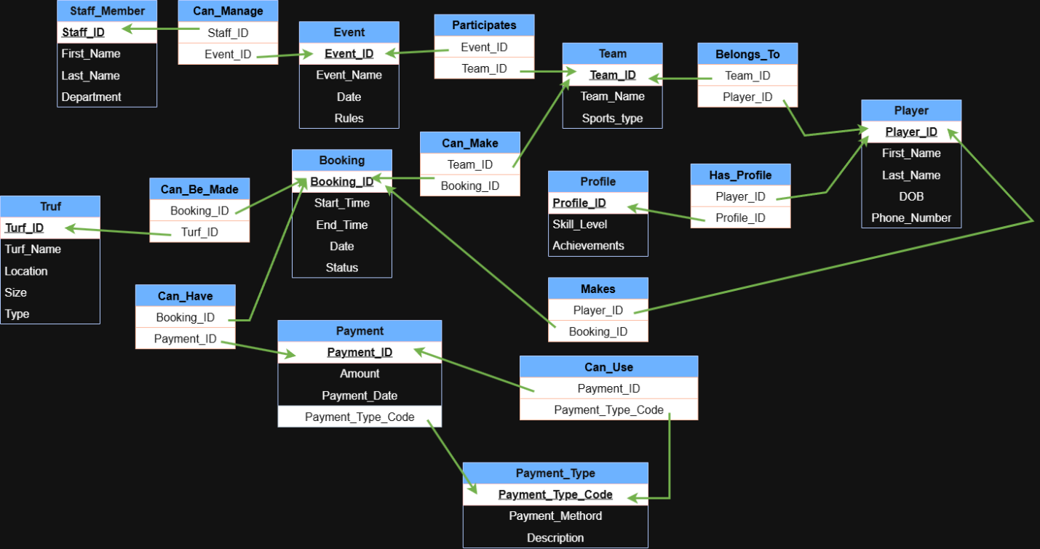
Fig-1: SCHEMA DIAGRAM

- USER INTERFACE: (Figma)
Figma Live link:
https://www.figma.com/design/gu6MmmA9LLIFNvthsJOYzK/Outdoor-sports-management?node-id=0-1&p=f&t=R19DcoDAKIZGseXV-0
 | 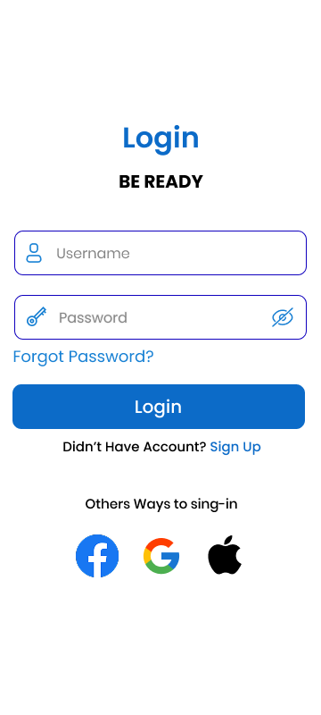
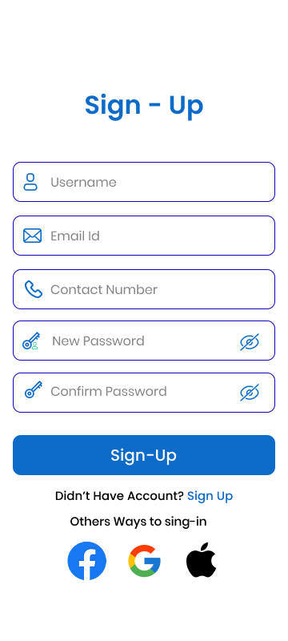 | 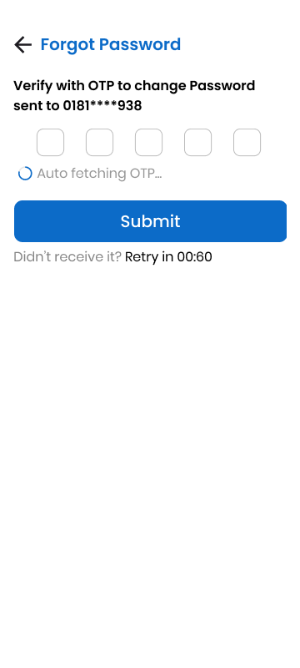
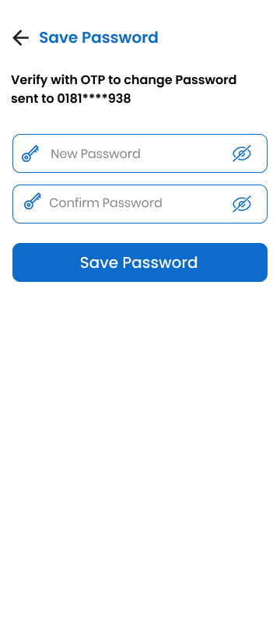 | 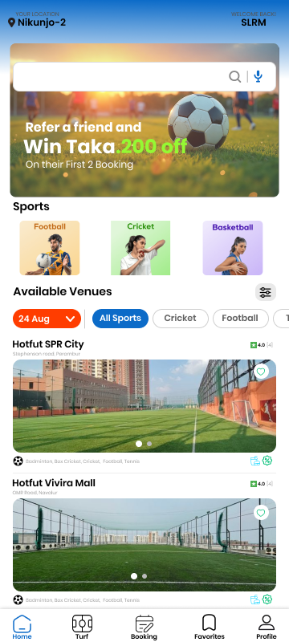
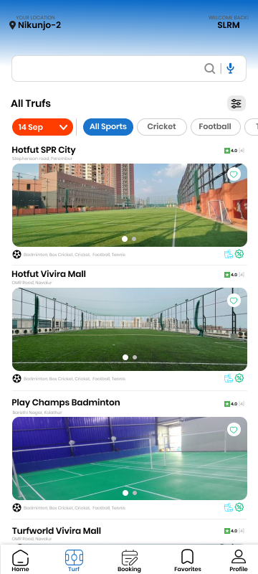 | 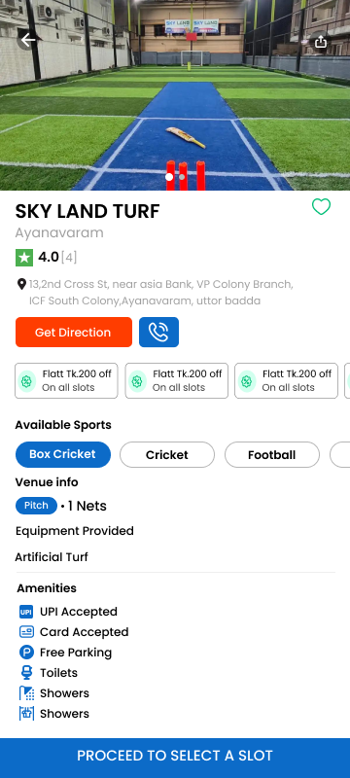
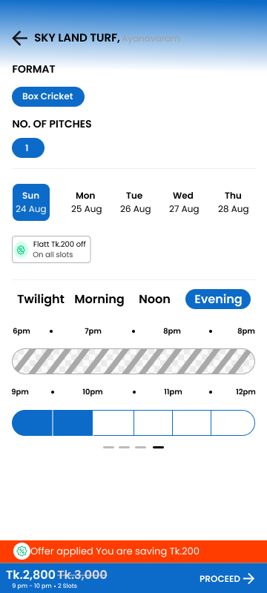 | 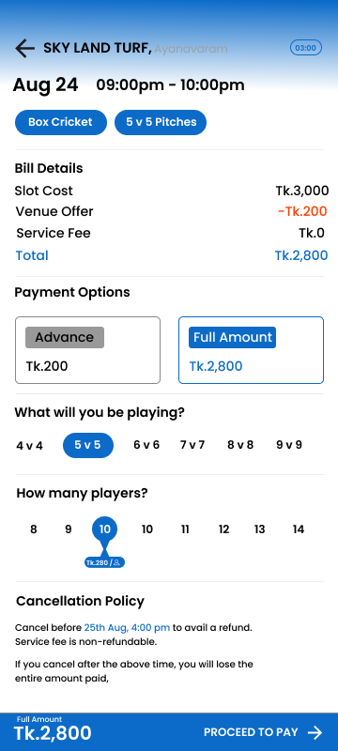
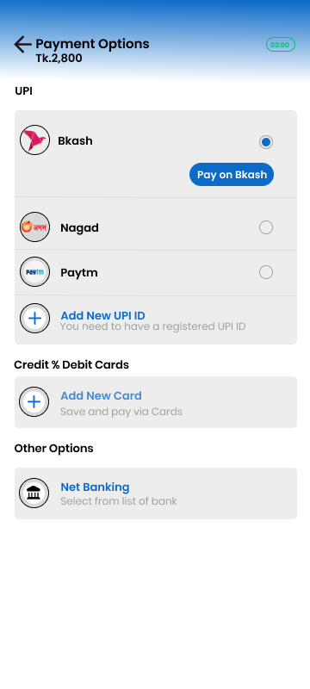 | 
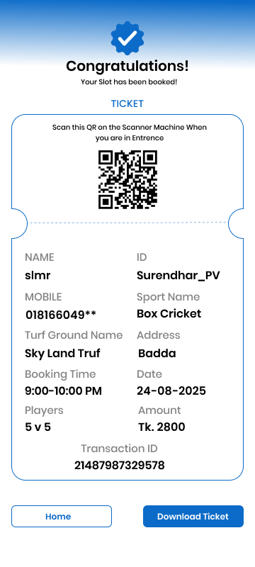 | 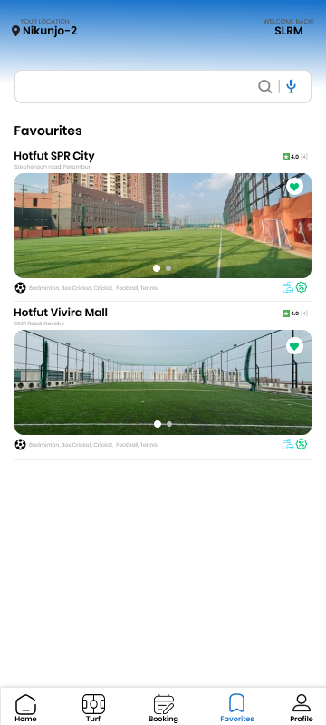
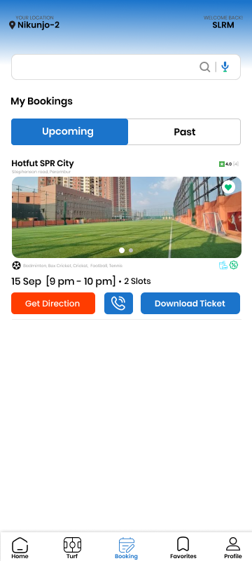 | 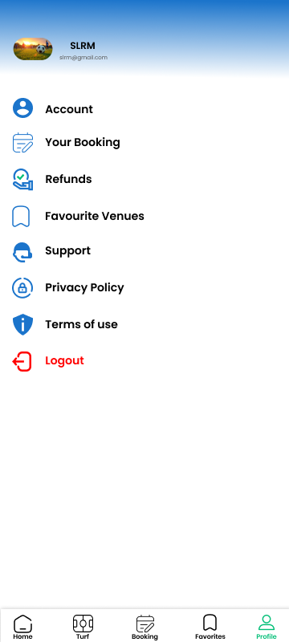

- Advance PL/SQL:
  - Stored function
Question-1: Create a function to retrieve the skill level of a player based on their Player_ID.
Answer:
-- Project: Outdoor Sports Management System
-- Semester: Summer 2025
-- Course Name: Advance Database Management Systems
-- Section: A

CREATE OR REPLACE FUNCTION get_skill_level (p_player_id IN NUMBER)
RETURN VARCHAR2 IS
v_skill_level VARCHAR2(50);
BEGIN

SELECT pr.Skill_Level
INTO v_skill_level
FROM Profile pr
JOIN Has_Profile hp ON pr.Profile_ID = hp.Profile_ID
WHERE hp.Player_ID = p_player_id;

RETURN v_skill_level;

EXCEPTION
WHEN NO_DATA_FOUND THEN
RETURN 'No skill level found for this player';
WHEN OTHERS THEN
RETURN 'Error retrieving skill level';
END get_skill_level;
/
To see the answer
-- Project: Outdoor Sports Management System
-- Semester: Summer 2025
-- Course Name: Advance Database Management Systems
-- Section: A

DECLARE
v_player_id NUMBER := 1;
v_skill_level VARCHAR2(50);
BEGIN
v_skill_level := get_skill_level(v_player_id);
DBMS_OUTPUT.PUT_LINE('Skill Level of Player ' || v_player_id || ': ' || v_skill_level);
END;
/
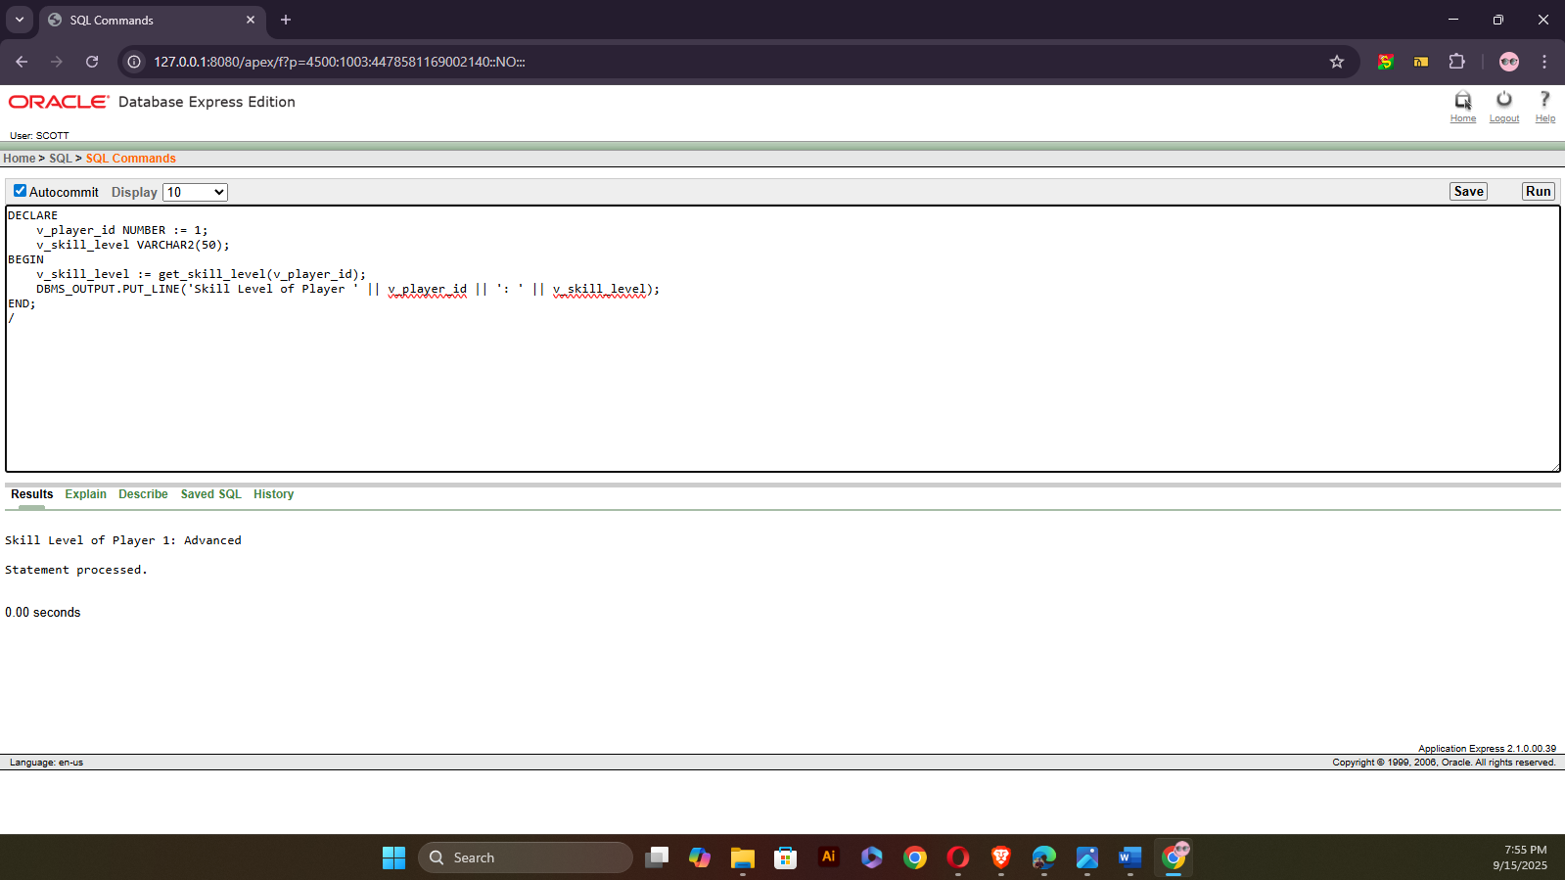
Question-2: Create a function to retrieve the turf location based on the Booking_ID.
Answer:
-- Project: Outdoor Sports Management System
-- Semester: Summer 2025
-- Course Name: Advance Database Management Systems
-- Section: A

CREATE OR REPLACE FUNCTION get_turf_location (p_booking_id IN NUMBER)
RETURN VARCHAR2 IS
v_turf_location VARCHAR2(100);
BEGIN

SELECT t.Turf_location
INTO v_turf_location
FROM Turf t
JOIN Can_Be_Made cbm ON t.Turf_ID = cbm.Turf_ID
WHERE cbm.Booking_ID = p_booking_id;

RETURN v_turf_location;

EXCEPTION
WHEN NO_DATA_FOUND THEN
RETURN 'No turf location found for this booking';
WHEN OTHERS THEN
RETURN 'Error retrieving turf location';
END get_turf_location;
/
To see the answer:
-- to see the function
-- Project: Outdoor Sports Management System
-- Semester: Summer 2025
-- Course Name: Advance Database Management Systems
-- Section: A

DECLARE
v_booking_id NUMBER := 2;
v_turf_location VARCHAR2(100);
BEGIN

v_turf_location := get_turf_location(v_booking_id);
DBMS_OUTPUT.PUT_LINE('Turf Location for Booking ' || v_booking_id || ': ' || v_turf_location);
END;
/
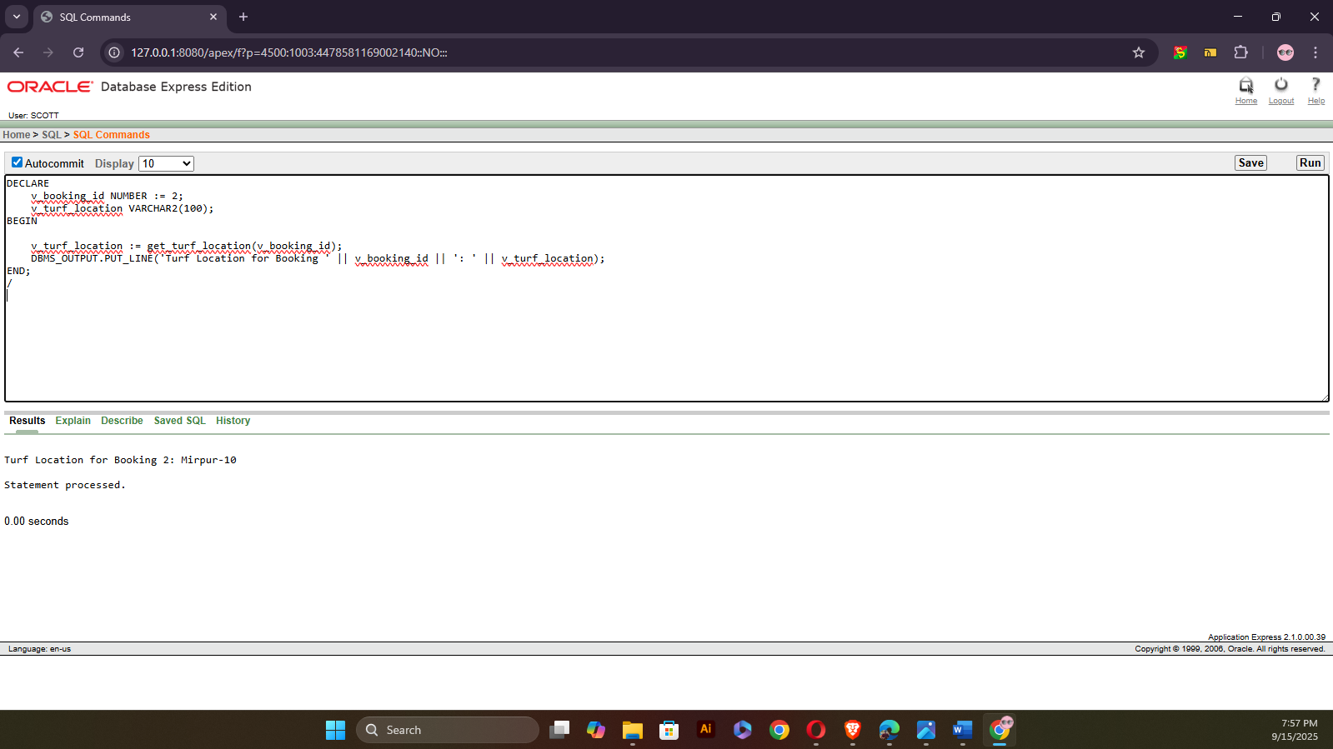

  - Stored procedure
Question-1: Create a stored procedure to update the skill level of a player based on their Player_ID
Answer:
-- Project: Outdoor Sports Management System
-- Semester: Summer 2025
-- Course Name: Advance Database Management Systems
-- Section: A

CREATE OR REPLACE PROCEDURE update_skill_level (p_player_id IN NUMBER, p_skill_level IN VARCHAR2)
IS
BEGIN

UPDATE Profile
SET Skill_Level = p_skill_level
WHERE Profile_ID = (SELECT Profile_ID FROM Has_Profile WHERE Player_ID = p_player_id);

IF SQL%ROWCOUNT = 0 THEN
RAISE_APPLICATION_ERROR(-20001, 'No player found with the given Player_ID');
END IF;

COMMIT;

EXCEPTION
WHEN NO_DATA_FOUND THEN
DBMS_OUTPUT.PUT_LINE('No matching player found.');
WHEN OTHERS THEN
DBMS_OUTPUT.PUT_LINE('Error updating skill level: ' || SQLERRM);
END update_skill_level;
/
To test the procedure:
-- to see the function
-- Project: Outdoor Sports Management System
-- Semester: Summer 2025
-- Course Name: Advance Database Management Systems
-- Section: A

BEGIN
-- Call the procedure to update the skill level of a player
update_skill_level(1, 'Advanced');
END;
/
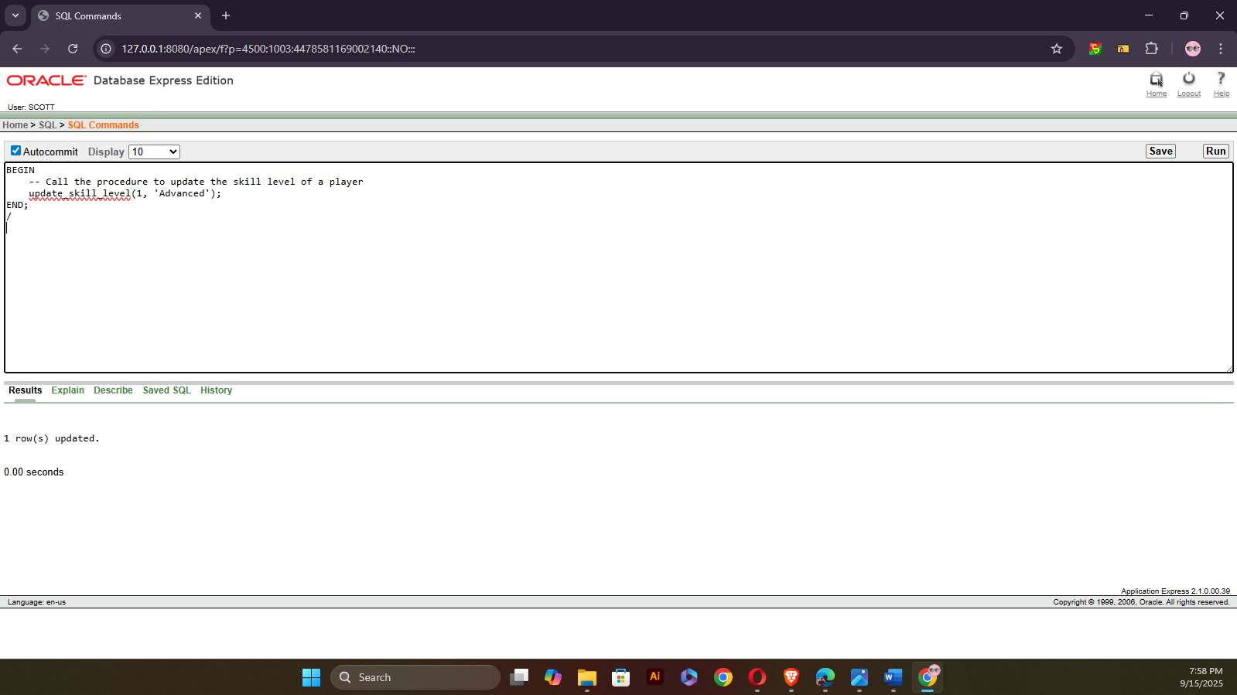
Question-2: Create a stored procedure to update the booking status of a specific booking based on the Booking_ID.
Answer:
-- Project: Outdoor Sports Management System
-- Semester: Summer 2025
-- Course Name: Advance Database Management Systems
-- Section: A

CREATE OR REPLACE PROCEDURE update_booking_status (p_booking_id IN NUMBER, p_status IN VARCHAR2)
IS
BEGIN

UPDATE Booking
SET Status = p_status
WHERE Booking_ID = p_booking_id;

IF SQL%ROWCOUNT = 0 THEN
RAISE_APPLICATION_ERROR(-20002, 'No booking found with the given Booking_ID');
END IF;

COMMIT;

EXCEPTION
WHEN NO_DATA_FOUND THEN
DBMS_OUTPUT.PUT_LINE('No booking found.');
WHEN OTHERS THEN
DBMS_OUTPUT.PUT_LINE('Error updating booking status: ' || SQLERRM);
END update_booking_status;
/
To test the procedure:
-- Project: Outdoor Sports Management System
-- Semester: Summer 2025
-- Course Name: Advance Database Management Systems
-- Section: A
BEGIN
update_booking_status(4, 'Confirmed');
END;
/
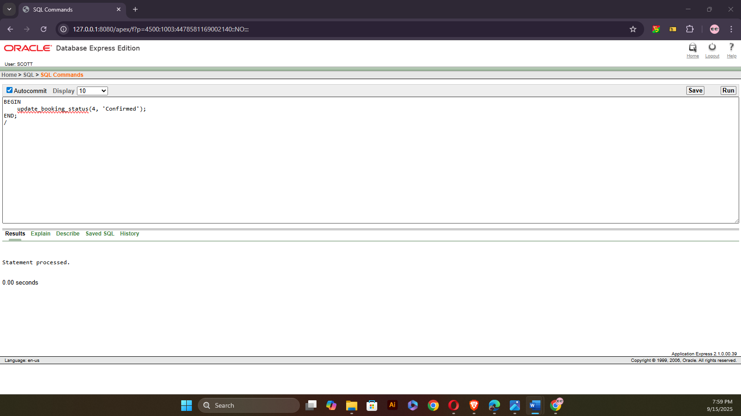
  - Table record
Question-1: Create a table-based record type to store player data and loop through it.
Answer:
-- Project: Outdoor Sports Management System
-- Semester: Summer 2025
-- Course Name: Advance Database Management Systems
-- Section: A

DECLARE
TYPE player_record_type IS TABLE OF Players%ROWTYPE;
v_players player_record_type;
BEGIN

SELECT * BULK COLLECT INTO v_players FROM Players;

IF v_players.COUNT = 0 THEN
DBMS_OUTPUT.PUT_LINE('No players found.');
ELSE
FOR i IN 1..v_players.COUNT LOOP
DBMS_OUTPUT.PUT_LINE('Player Name: ' || v_players(i).First_Name || ' ' || v_players(i).Last_Name);
END LOOP;
END IF;

EXCEPTION
WHEN NO_DATA_FOUND THEN
DBMS_OUTPUT.PUT_LINE('No player records available.');
WHEN OTHERS THEN
DBMS_OUTPUT.PUT_LINE('Error retrieving player records: ' || SQLERRM);
END;
/
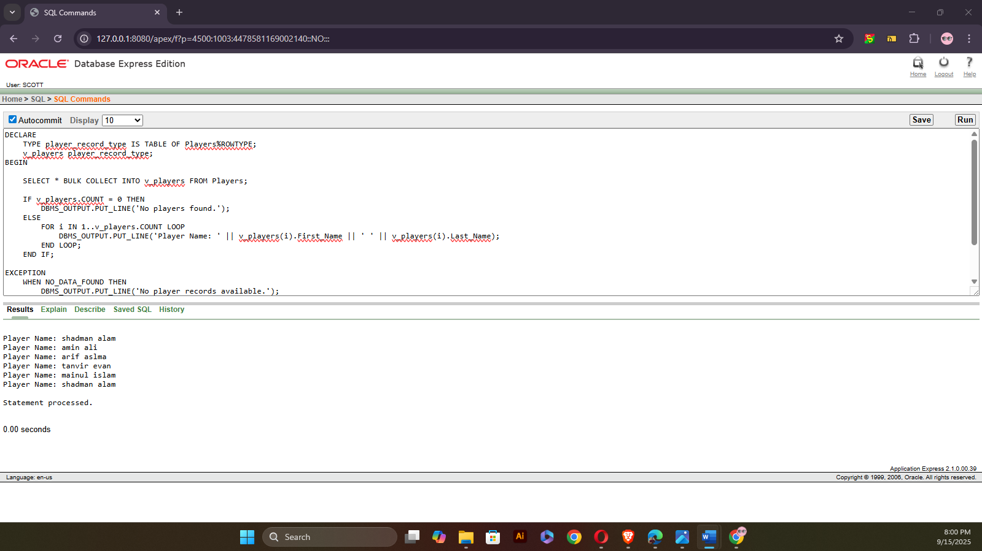
Question-2: Create a table-based record type to store booking data and loop through it.
Answer:
-- Project: Outdoor Sports Management System
-- Semester: Summer 2025
-- Course Name: Advance Database Management Systems
-- Section: A

DECLARE
TYPE booking_record_type IS TABLE OF Booking%ROWTYPE;
v_bookings booking_record_type;
BEGIN
SELECT * BULK COLLECT INTO v_bookings FROM Booking;

IF v_bookings.COUNT = 0 THEN
DBMS_OUTPUT.PUT_LINE('No bookings found.');
ELSE
FOR i IN 1..v_bookings.COUNT LOOP
DBMS_OUTPUT.PUT_LINE('Booking ID: ' || v_bookings(i).Booking_ID ||
' - Status: ' || v_bookings(i).Status);
END LOOP;
END IF;

EXCEPTION
WHEN NO_DATA_FOUND THEN
DBMS_OUTPUT.PUT_LINE('No booking records available.');
WHEN OTHERS THEN
DBMS_OUTPUT.PUT_LINE('Error retrieving booking records: ' || SQLERRM);
END;
/
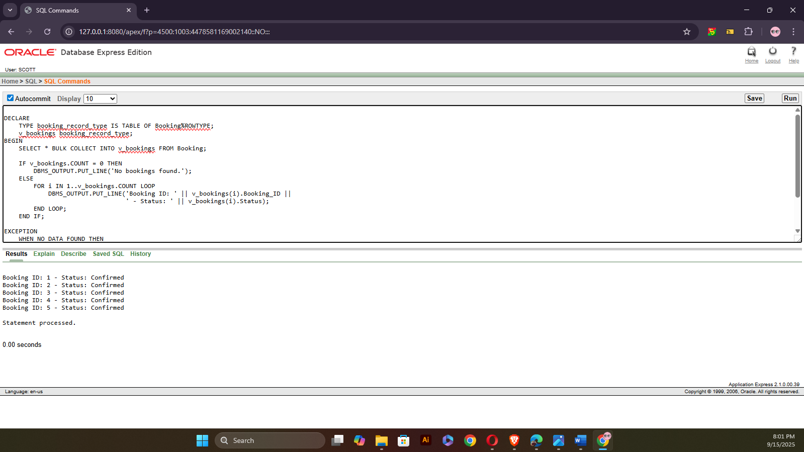

  - Explicit cursor
Question-1: Create an explicit cursor to fetch players with their booking details.
Answer:
-- Project: Outdoor Sports Management System
-- Semester: Summer 2025
-- Course Name: Advance Database Management Systems
-- Section: A

DECLARE
CURSOR c_player_bookings IS
SELECT p.Player_ID, b.Booking_ID, b.Status
FROM Players p
JOIN Belongs_To bt ON p.Player_ID = bt.Player_ID
JOIN Can_Make cm ON bt.Team_ID = cm.Team_ID
JOIN Booking b ON cm.Booking_ID = b.Booking_ID;

v_player_booking c_player_bookings%ROWTYPE;
BEGIN
OPEN c_player_bookings;
LOOP
FETCH c_player_bookings INTO v_player_booking;
EXIT WHEN c_player_bookings%NOTFOUND;
DBMS_OUTPUT.PUT_LINE('Player ID: ' || v_player_booking.Player_ID ||
', Booking ID: ' || v_player_booking.Booking_ID ||
', Status: ' || v_player_booking.Status);
END LOOP;
CLOSE c_player_bookings;

EXCEPTION
WHEN NO_DATA_FOUND THEN
DBMS_OUTPUT.PUT_LINE('No player booking records found.');
WHEN OTHERS THEN
DBMS_OUTPUT.PUT_LINE('Error fetching player bookings: ' || SQLERRM);
END;
/
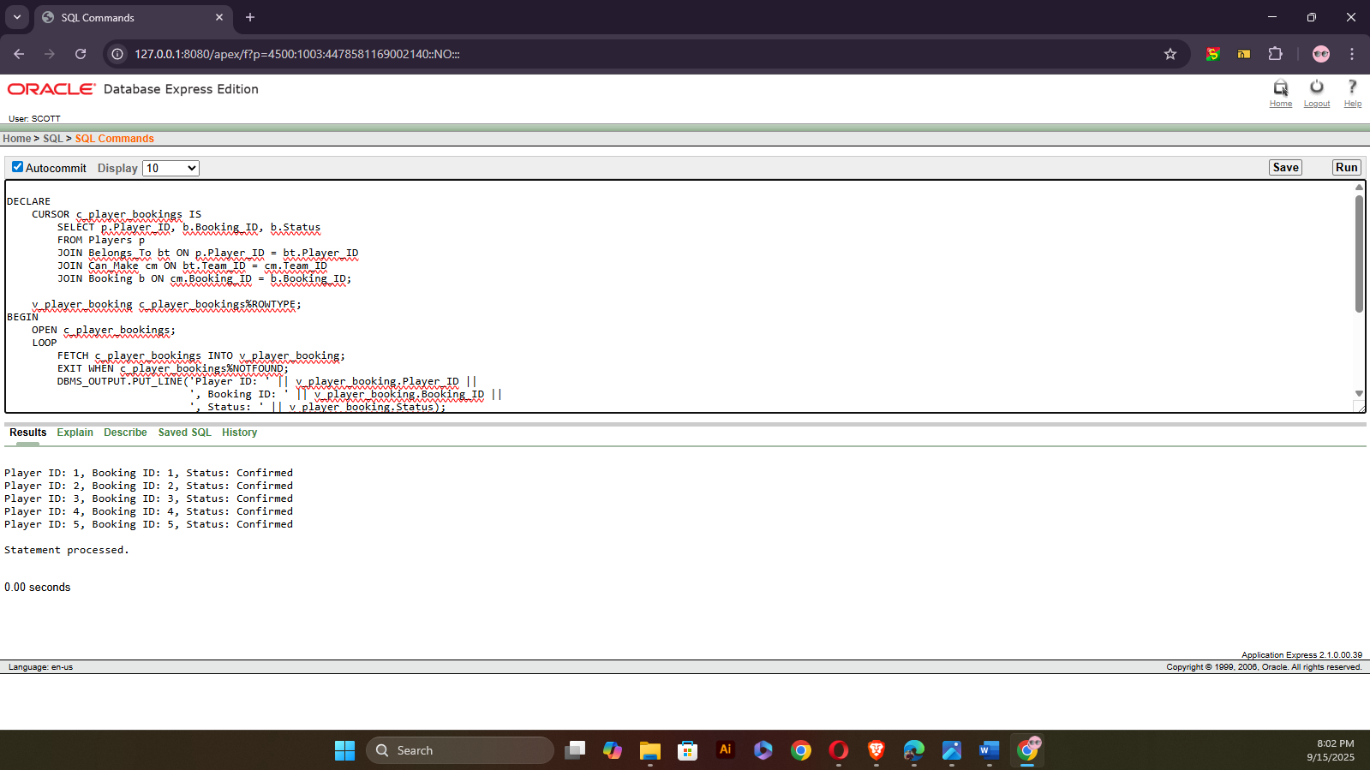
Question-2: Create an explicit cursor to fetch the booking details (Booking ID, Start Time, and End Time) for a specific team.
Answer:
-- Project: Outdoor Sports Management System
-- Semester: Summer 2025
-- Course Name: Advance Database Management Systems
-- Section: A

DECLARE
CURSOR c_team_bookings IS
SELECT b.Booking_ID, b.Start_Time, b.End_Time
FROM Booking b
JOIN Can_Make cm ON b.Booking_ID = cm.Booking_ID
WHERE cm.Team_ID = 1;

v_team_booking c_team_bookings%ROWTYPE;
BEGIN
OPEN c_team_bookings;
LOOP
FETCH c_team_bookings INTO v_team_booking;
EXIT WHEN c_team_bookings%NOTFOUND;

DBMS_OUTPUT.PUT_LINE('Booking ID: ' || v_team_booking.Booking_ID ||
', Start Time: ' || v_team_booking.Start_Time ||
', End Time: ' || v_team_booking.End_Time);
END LOOP;
CLOSE c_team_bookings;

EXCEPTION
WHEN NO_DATA_FOUND THEN
DBMS_OUTPUT.PUT_LINE('No booking records found for the given team.');
WHEN OTHERS THEN
DBMS_OUTPUT.PUT_LINE('Error fetching team booking details: ' || SQLERRM);
END;
/
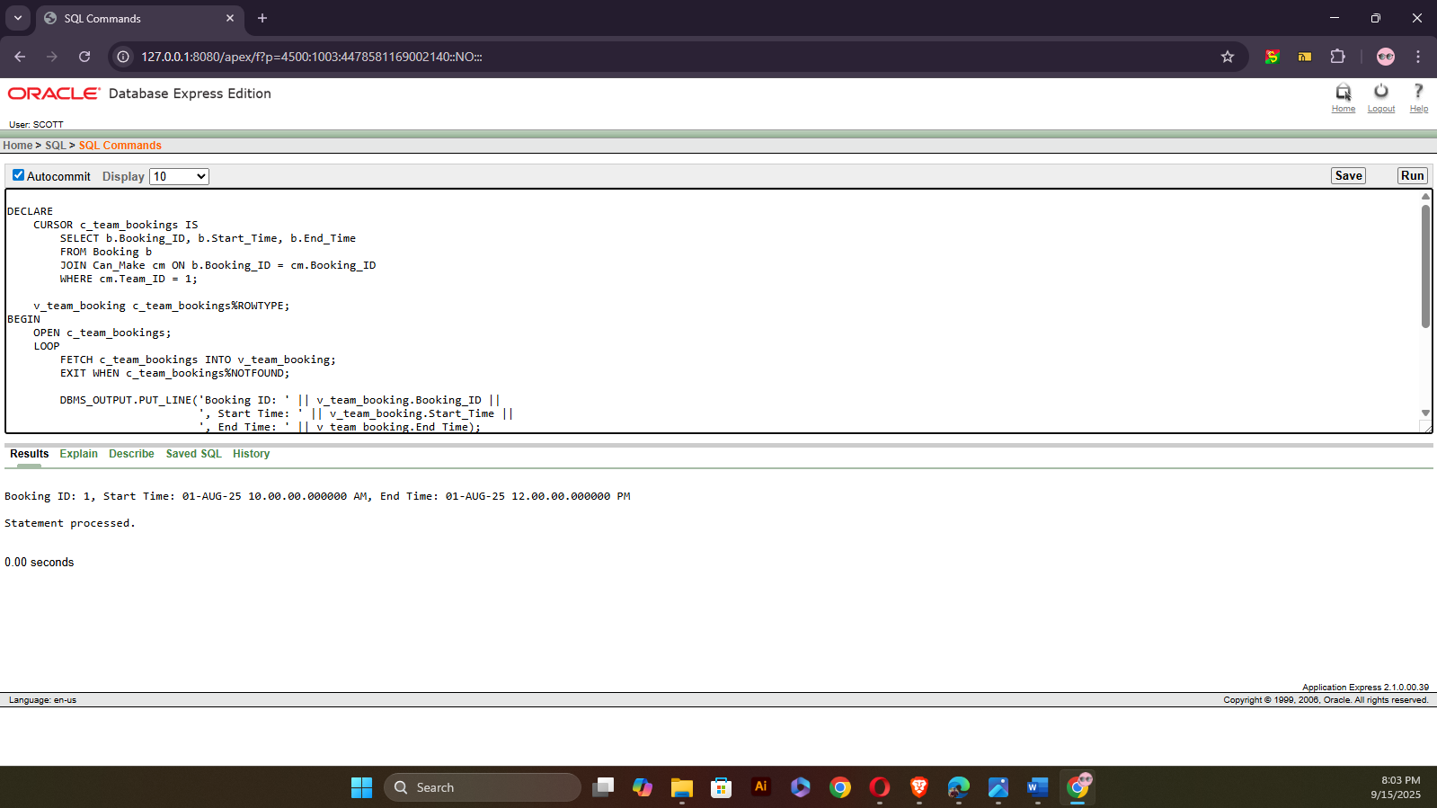
  - Cursor-based-record
Question-1: Use a cursor-based record to print the names of players who have confirmed bookings.
Answer:
-- Project: Outdoor Sports Management System
-- Semester: Summer 2025
-- Course Name: Advance Database Management Systems
-- Section: A

DECLARE
TYPE player_rec_type IS RECORD (
player_id NUMBER,
first_name VARCHAR2(100),
last_name VARCHAR2(100)
);

TYPE player_tab_type IS TABLE OF player_rec_type;

v_players player_tab_type;
BEGIN
SELECT p.Player_ID, p.First_Name, p.Last_Name
BULK COLLECT INTO v_players
FROM Players p
JOIN Belongs_To bt ON p.Player_ID = bt.Player_ID
JOIN Can_Make cm ON bt.Team_ID = cm.Team_ID
JOIN Booking b ON cm.Booking_ID = b.Booking_ID
WHERE b.Status = 'Confirmed';

IF v_players.COUNT = 0 THEN
DBMS_OUTPUT.PUT_LINE('No players with confirmed bookings found.');
ELSE
FOR i IN 1..v_players.COUNT LOOP
DBMS_OUTPUT.PUT_LINE('Player Name: ' || v_players(i).first_name || ' ' || v_players(i).last_name);
END LOOP;
END IF;

EXCEPTION
WHEN NO_DATA_FOUND THEN
DBMS_OUTPUT.PUT_LINE('No confirmed booking records found.');
WHEN OTHERS THEN
DBMS_OUTPUT.PUT_LINE('Error retrieving confirmed booking players: ' || SQLERRM);
END;
/
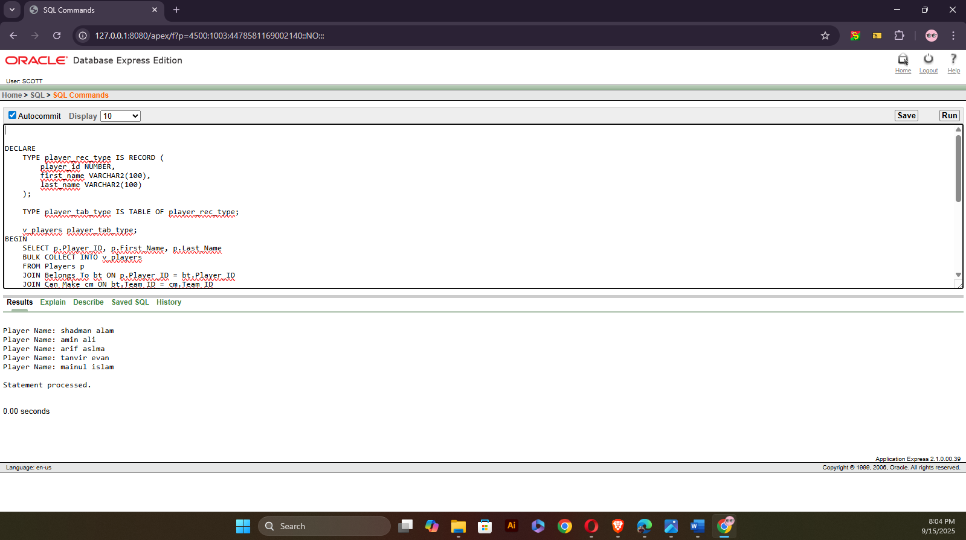
Question-2: Use a cursor-based record to print the player names and their associated team names.
Answer:
-- Project: Outdoor Sports Management System
-- Semester: Summer 2025
-- Course Name: Advance Database Management Systems
-- Section: A

DECLARE
TYPE player_team_rec_type IS RECORD (
player_name VARCHAR2(100),
team_name VARCHAR2(100)
);

TYPE player_team_tab_type IS TABLE OF player_team_rec_type;

v_player_teams player_team_tab_type;
BEGIN
SELECT p.First_Name || ' ' || p.Last_Name AS player_name, t.Team_Name
BULK COLLECT INTO v_player_teams
FROM Players p
JOIN Belongs_To bt ON p.Player_ID = bt.Player_ID
JOIN Team t ON bt.Team_ID = t.Team_ID;

IF v_player_teams.COUNT = 0 THEN
DBMS_OUTPUT.PUT_LINE('No player-team records found.');
ELSE
FOR i IN 1..v_player_teams.COUNT LOOP
DBMS_OUTPUT.PUT_LINE('Player: ' || v_player_teams(i).player_name ||
' - Team: ' || v_player_teams(i).team_name);
END LOOP;
END IF;

EXCEPTION
WHEN NO_DATA_FOUND THEN
DBMS_OUTPUT.PUT_LINE('No player-team records available.');
WHEN OTHERS THEN
DBMS_OUTPUT.PUT_LINE('Error retrieving player-team records: ' || SQLERRM);
END;
/
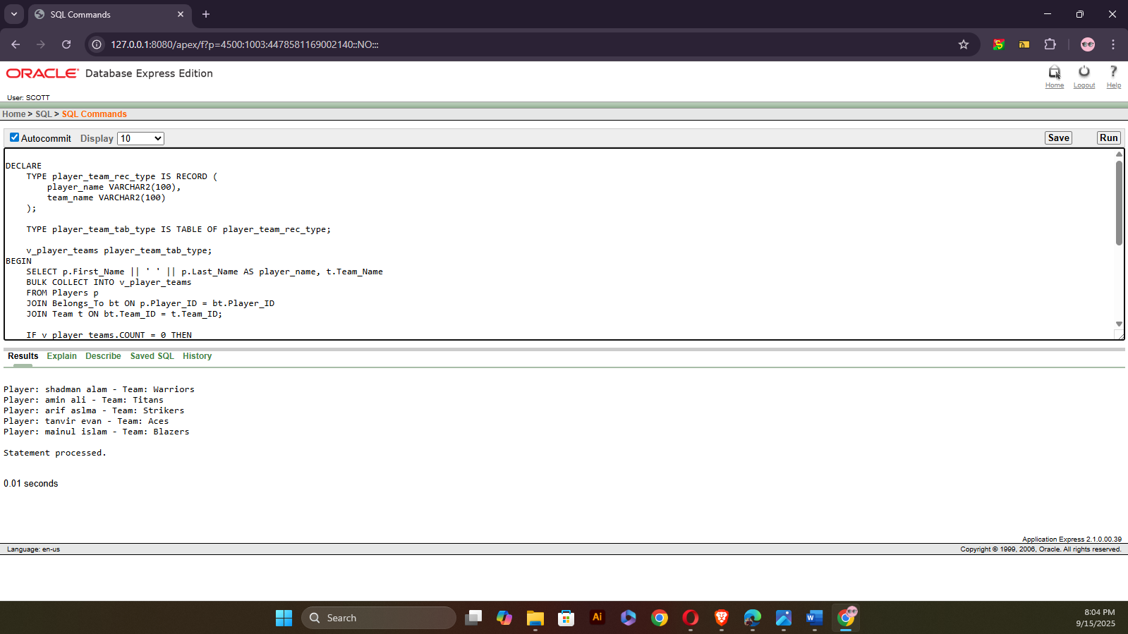
  - Row level trigger
Question-1: Create a row-level trigger that automatically sets the booking status to 'Pending' when a new booking record is inserted.
Answer:
-- Project: Outdoor Sports Management System
-- Semester: Summer 2025
-- Course Name: Advance Database Management Systems
-- Section: A

CREATE OR REPLACE TRIGGER trg_booking_default_status
BEFORE INSERT ON Booking
FOR EACH ROW
BEGIN
:NEW.Status := 'Pending';

EXCEPTION
WHEN OTHERS THEN
DBMS_OUTPUT.PUT_LINE('Error in trg_booking_default_status trigger: ' || SQLERRM);
END;
/
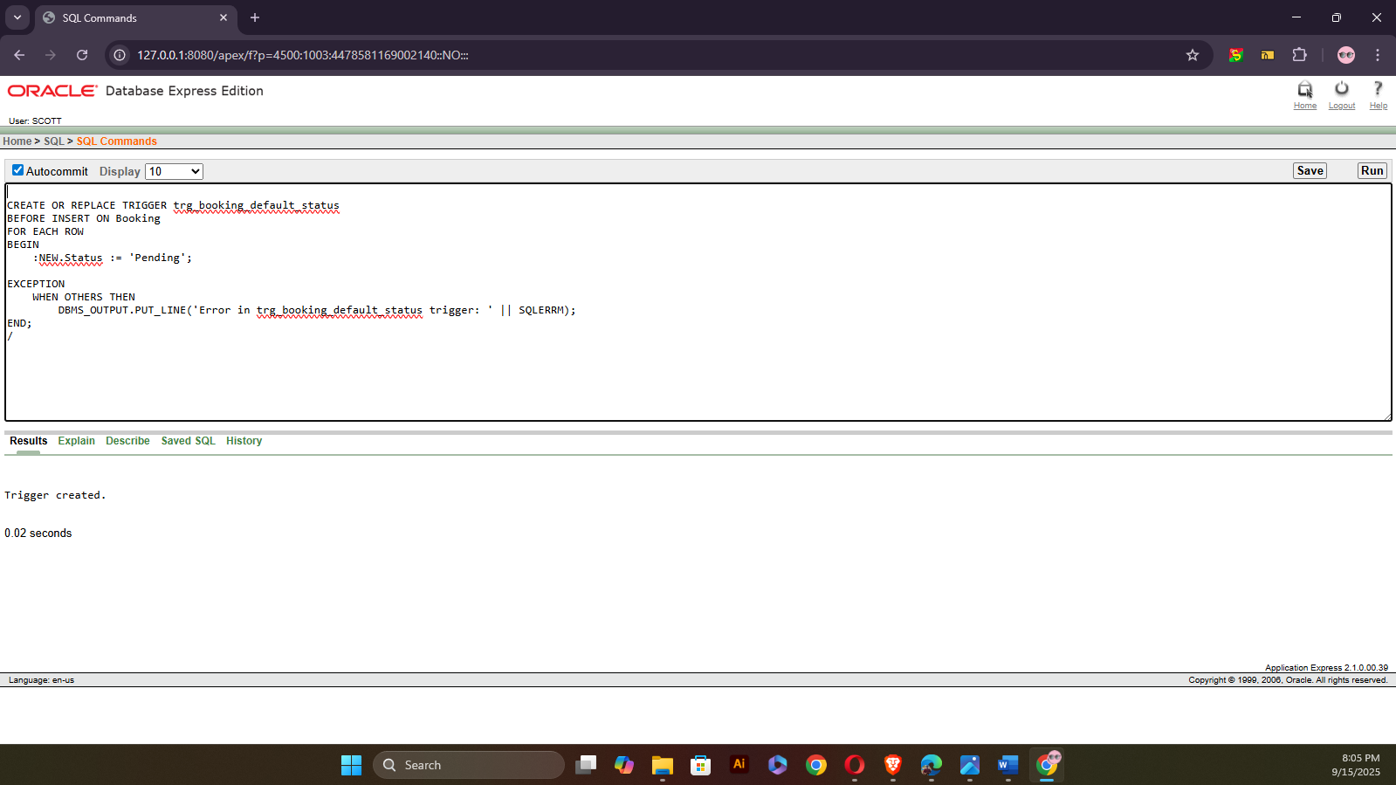
Question-2: Write a row-level trigger on the Players table that displays the name of a newly inserted player.
Answer:
-- Project: Outdoor Sports Management System
-- Semester: Summer 2025
-- Course Name: Advance Database Management Systems
-- Section: A

CREATE OR REPLACE TRIGGER trg_player_insert
AFTER INSERT ON Players
FOR EACH ROW
BEGIN
DBMS_OUTPUT.PUT_LINE('New Player Added: ' || :NEW.First_Name || ' ' || :NEW.Last_Name);

EXCEPTION
WHEN OTHERS THEN
DBMS_OUTPUT.PUT_LINE('Error in trg_player_insert trigger: ' || SQLERRM);
END;
/
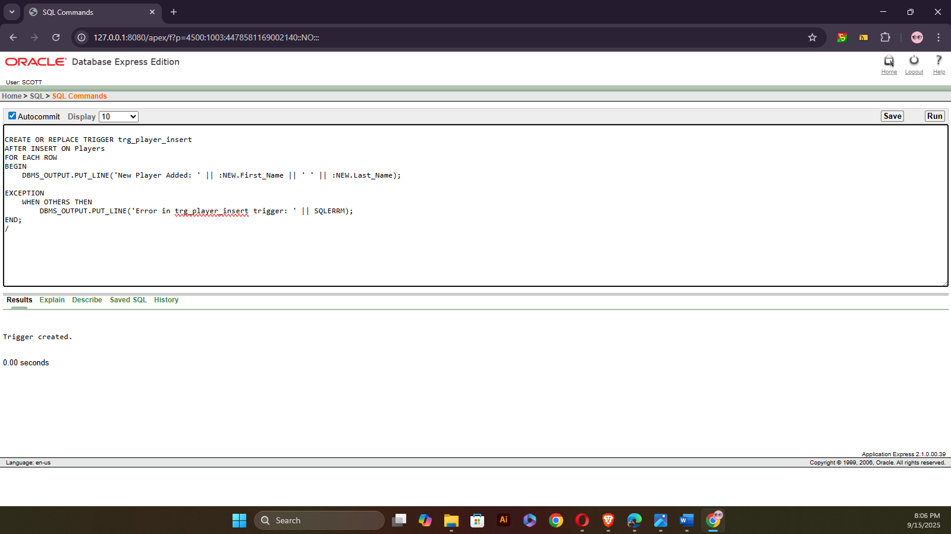

7. Statement level trigger
Question-1: Write a statement-level trigger that prints a message whenever a new event is inserted into the Events table.
Answer:
-- Project: Outdoor Sports Management System
-- Semester: Summer 2025
-- Course Name: Advance Database Management Systems
-- Section: A

CREATE OR REPLACE TRIGGER trg_event_insert_stmt
AFTER INSERT ON Events
BEGIN
DBMS_OUTPUT.PUT_LINE('An INSERT operation has been performed on Events table.');

EXCEPTION
WHEN OTHERS THEN
DBMS_OUTPUT.PUT_LINE('Error in trg_event_insert_stmt trigger: ' || SQLERRM);
END;
/
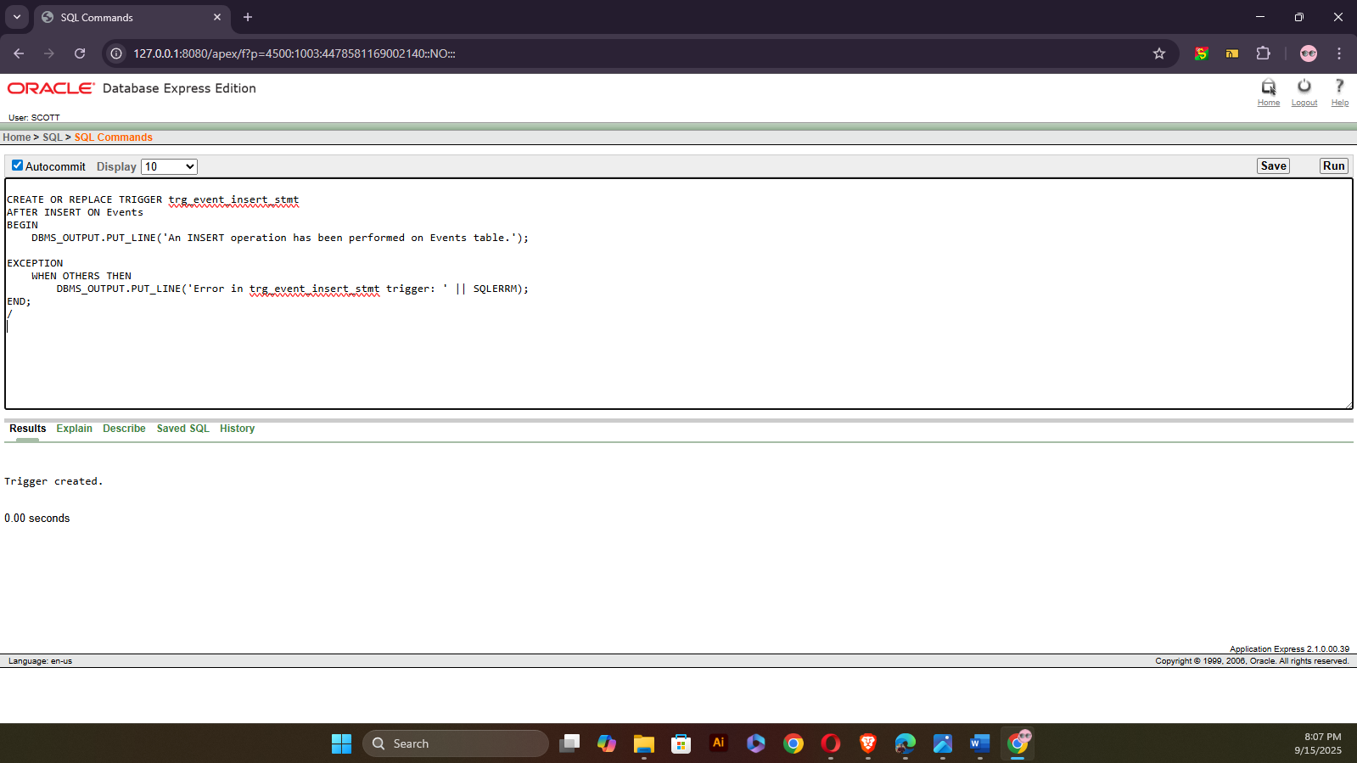
Question-2: Write a statement-level trigger that prints a message before any row is deleted from the Team table
Answer:
-- Project: Outdoor Sports Management System
-- Semester: Summer 2025
-- Course Name: Advance Database Management Systems
-- Section: A

CREATE OR REPLACE TRIGGER trg_team_delete_stmt
BEFORE DELETE ON Team
BEGIN
DBMS_OUTPUT.PUT_LINE('A DELETE operation is being performed on Team table.');

EXCEPTION
WHEN OTHERS THEN
DBMS_OUTPUT.PUT_LINE('Error in trg_team_delete_stmt trigger: ' || SQLERRM);
END;
/
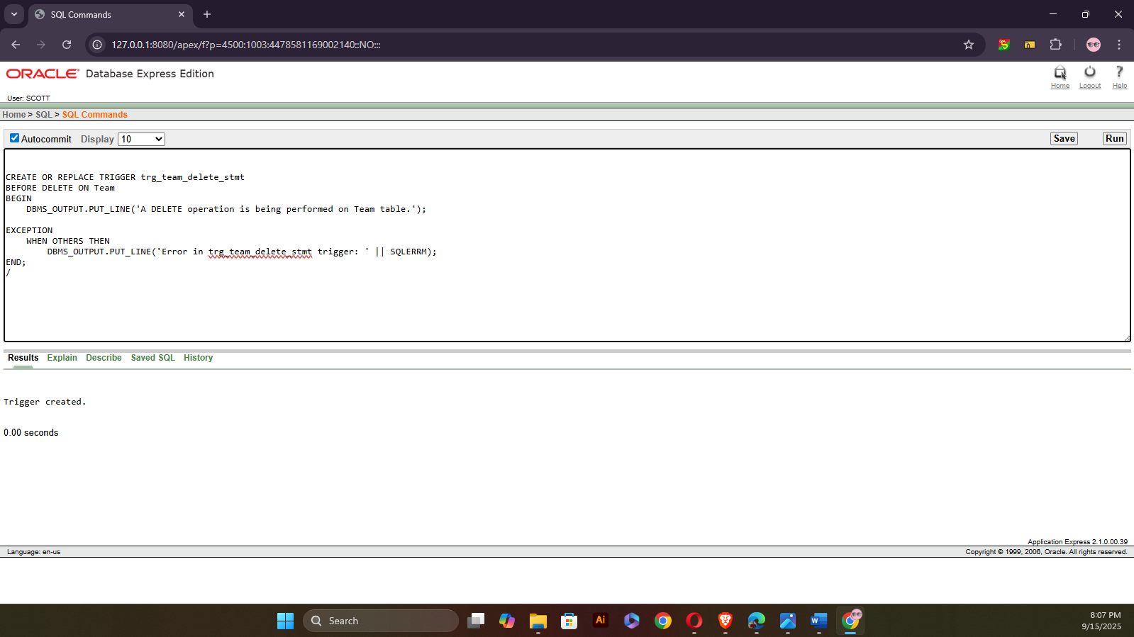
8. package
Question-1: Create a PL/SQL package named player_pack that contains procedures to display a player’s full name and date of birth from the Players table.
Answer:
-- Project: Outdoor Sports Management System
-- Semester: Summer 2025
-- Course Name: Advance Database Management Systems
-- Section: A
Specification
CREATE OR REPLACE PACKAGE player_pack AS
PROCEDURE show_player_name(p_id Players.Player_ID%TYPE);
PROCEDURE show_player_dob(p_id Players.Player_ID%TYPE);
END player_pack;
/
-- Project: Outdoor Sports Management System
-- Semester: Summer 2025
-- Course Name: Advance Database Management Systems
-- Section: A
Body
CREATE OR REPLACE PACKAGE BODY player_pack AS

PROCEDURE show_player_name(p_id Players.Player_ID%TYPE) IS
p_name VARCHAR2(100);
BEGIN
SELECT First_Name || ' ' || Last_Name INTO p_name
FROM Players WHERE Player_ID = p_id;

DBMS_OUTPUT.PUT_LINE('Player Name: ' || p_name);

EXCEPTION
WHEN NO_DATA_FOUND THEN
DBMS_OUTPUT.PUT_LINE('No player found with ID: ' || p_id);
WHEN OTHERS THEN
DBMS_OUTPUT.PUT_LINE('Error in show_player_name: ' || SQLERRM);
END;

PROCEDURE show_player_dob(p_id Players.Player_ID%TYPE) IS
p_dob DATE;
BEGIN
SELECT DOB INTO p_dob
FROM Players WHERE Player_ID = p_id;

DBMS_OUTPUT.PUT_LINE('Date of Birth: ' || TO_CHAR(p_dob,'DD-MON-YYYY'));

EXCEPTION
WHEN NO_DATA_FOUND THEN
DBMS_OUTPUT.PUT_LINE('No player found with ID: ' || p_id);
WHEN OTHERS THEN
DBMS_OUTPUT.PUT_LINE('Error in show_player_dob: ' || SQLERRM);
END;

END player_pack;
/
-- Project: Outdoor Sports Management System
-- Semester: Summer 2025
-- Course Name: Advance Database Management Systems
-- Section: A
Usage
BEGIN
player_pack.show_player_name(1);
player_pack.show_player_dob(1);
END;
/
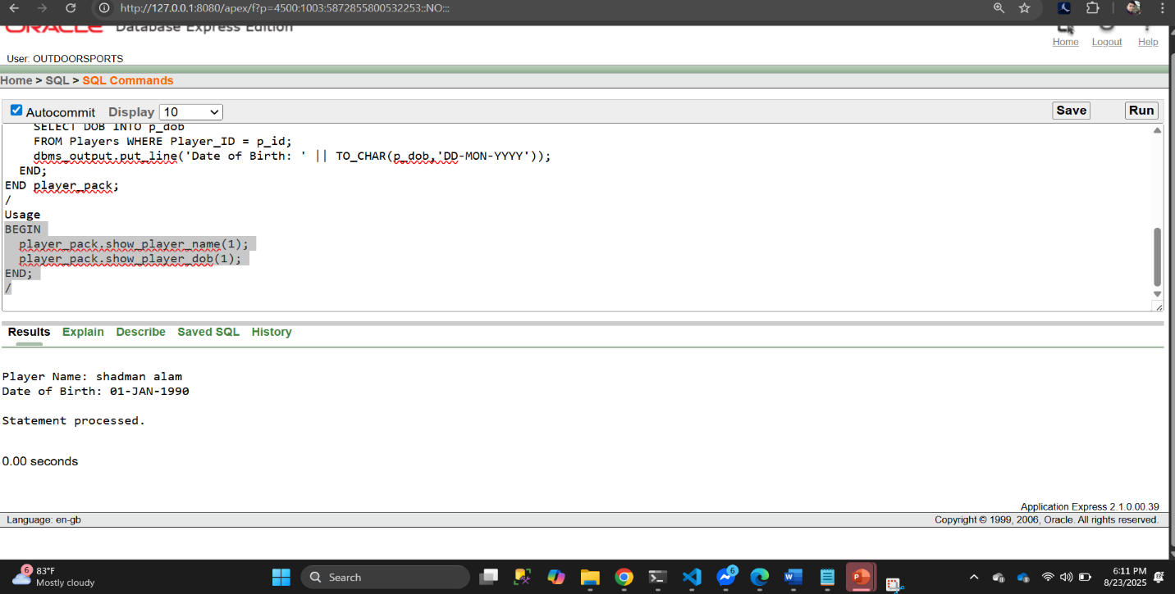
Question-2: Create a PL/SQL package named booking_pack that allows checking and updating the booking status in the Booking table.
Answer:
-- Project: Outdoor Sports Management System
-- Semester: Summer 2025
-- Course Name: Advance Database Management Systems
-- Section: A
Specification
CREATE OR REPLACE PACKAGE booking_pack AS
PROCEDURE show_booking_status(b_id Booking.Booking_ID%TYPE);
PROCEDURE update_booking_status(b_id Booking.Booking_ID%TYPE, new_status VARCHAR2);
END booking_pack;
/

-- Project: Outdoor Sports Management System
-- Semester: Summer 2025
-- Course Name: Advance Database Management Systems
-- Section: A

Body
CREATE OR REPLACE PACKAGE BODY booking_pack AS

PROCEDURE show_booking_status(b_id Booking.Booking_ID%TYPE) IS
v_status VARCHAR2(50);
BEGIN
SELECT Status INTO v_status
FROM Booking WHERE Booking_ID = b_id;

DBMS_OUTPUT.PUT_LINE('Booking Status: ' || v_status);

EXCEPTION
WHEN NO_DATA_FOUND THEN
DBMS_OUTPUT.PUT_LINE('No booking found with ID: ' || b_id);
WHEN OTHERS THEN
DBMS_OUTPUT.PUT_LINE('Error in show_booking_status: ' || SQLERRM);
END;

PROCEDURE update_booking_status(b_id Booking.Booking_ID%TYPE, new_status VARCHAR2) IS
BEGIN
UPDATE Booking SET Status = new_status WHERE Booking_ID = b_id;

IF SQL%ROWCOUNT = 0 THEN
DBMS_OUTPUT.PUT_LINE('No booking found with ID: ' || b_id);
ELSE
DBMS_OUTPUT.PUT_LINE('Booking ' || b_id || ' updated to ' || new_status);
END IF;

EXCEPTION
WHEN OTHERS THEN
DBMS_OUTPUT.PUT_LINE('Error in update_booking_status: ' || SQLERRM);
END;

END booking_pack;
/
-- Project: Outdoor Sports Management System
-- Semester: Summer 2025
-- Course Name: Advance Database Management Systems
-- Section: A

Usage
BEGIN
booking_pack.show_booking_status(1);
booking_pack.update_booking_status(2, 'Confirmed');
END;
/

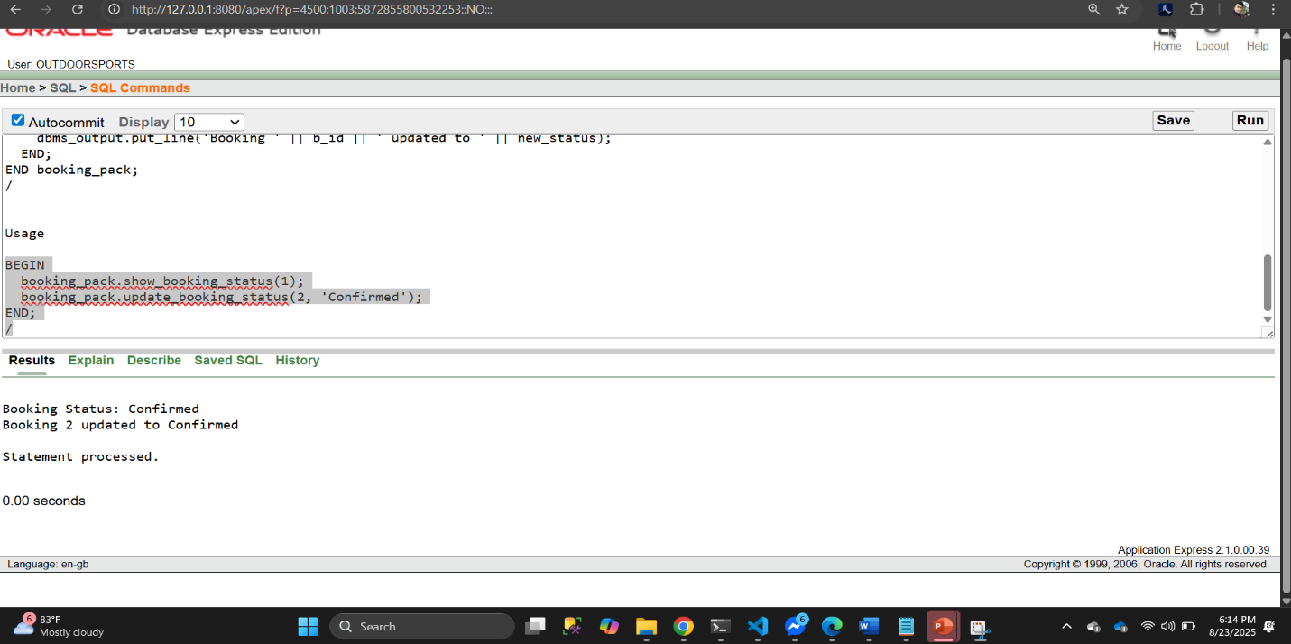

- RELATIONAL ALGEBRA:
Question 1:
Find the name and location of turfs that are available for booking.
Answer:
π_{Turf_Name, Location} (σ_{Status=”Available”} (Turf))
Question 2:
Find all players who have made a booking.
Answer:
π_{First_Name, Last_Name} (Players ⋈ Makes ⋈ Booking)
Question 3:
Retrieve the team names and the names of players in each team.
Answer:
πTeam_Name, First_Name, Last_Name (Team ⋈ Participates ⋈ Players)
Question 4:
List all booking details for a specific date.
Answer:
πBooking_ID, Start_Time, End_Time (σ_{Date=”YYYY-MM-DD”}(Booking))
Question 5:
Find all players who have a skill level of 'Advanced'.
Answer:
π_{First_Name, Last_Name} (Players ⋈ Has_Profile ⋈ Profile)
σ_{Skill_Level=”Advanced”} (Profile)

-Thank You-

